# Enable Shared Drives for Docker

If you add docker support to a new VS Solution, you will get a shar c drive type error.

Install docker for windows, once docker is running right click the icon in the task bar

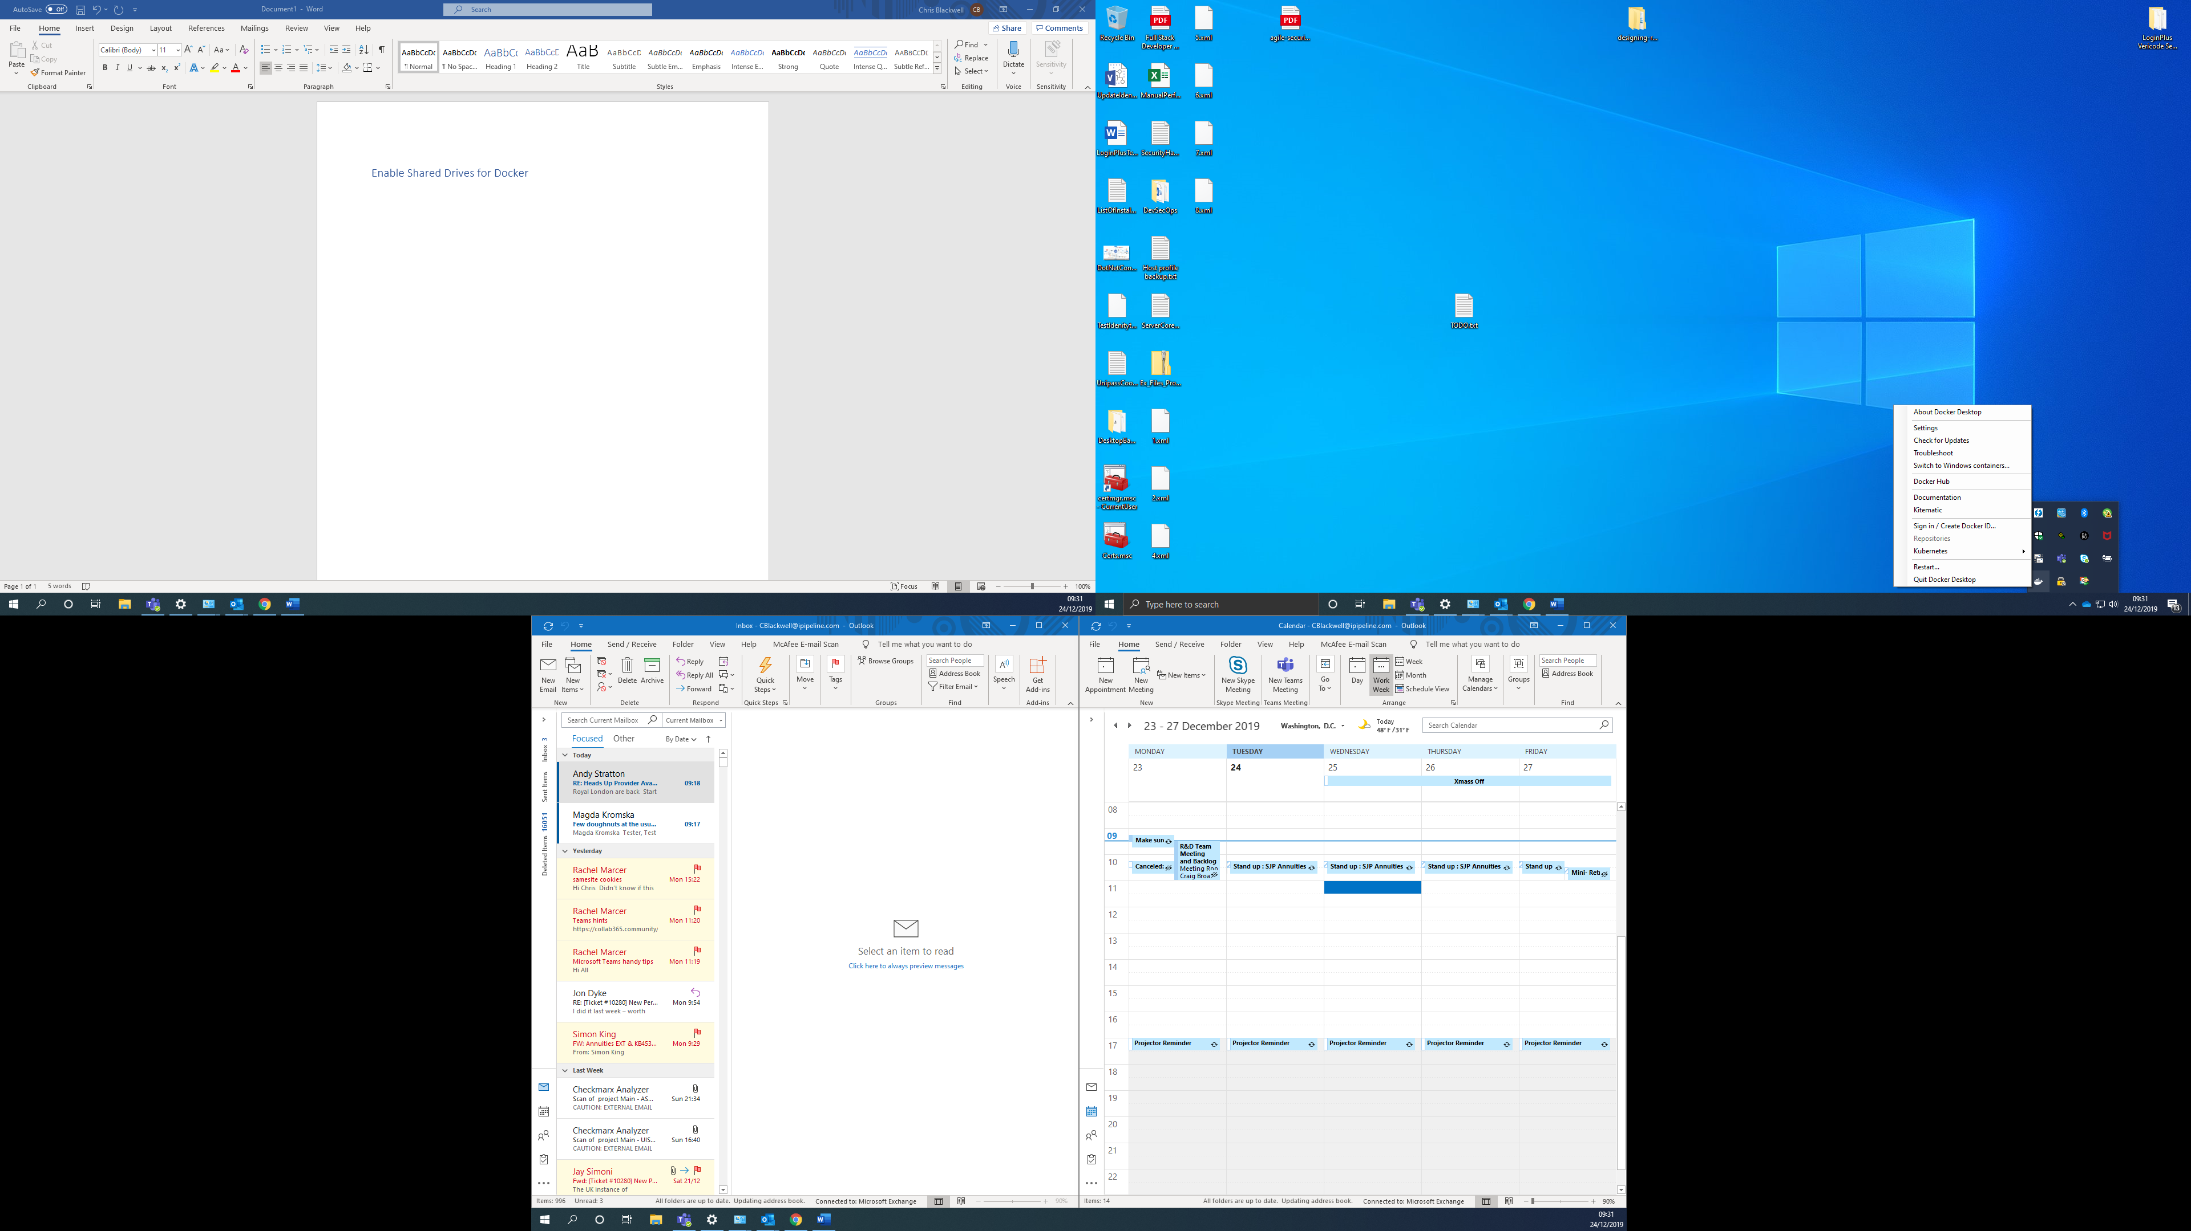

Click about docker to check your running the latest docker version, this guide works for 2.1.05

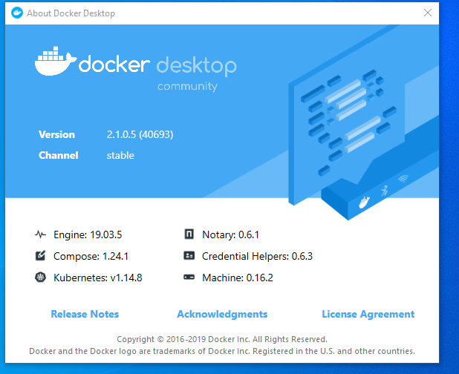

Right click again on the docker icon in the task bar, and click settings, then Share Drives

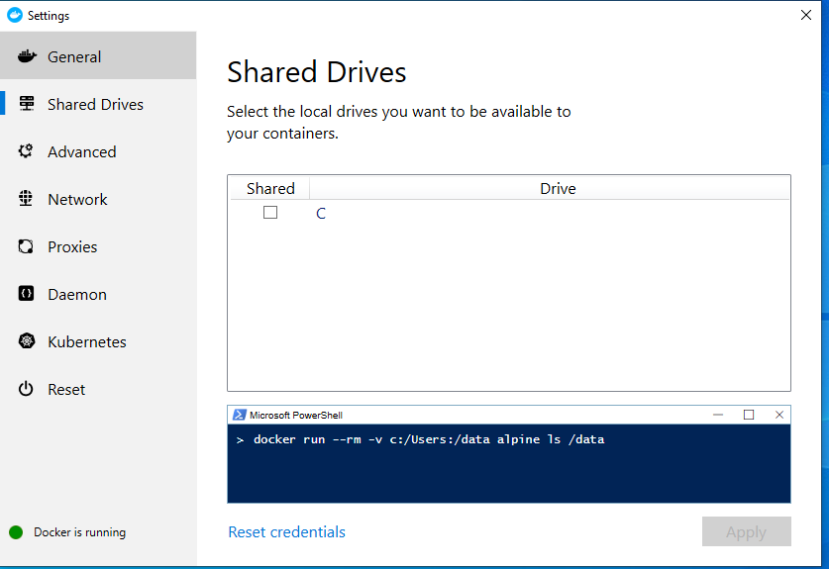

Check the tick box to share drive and you will get prompted to enter your domain password, it will display an error if you type it wrong.

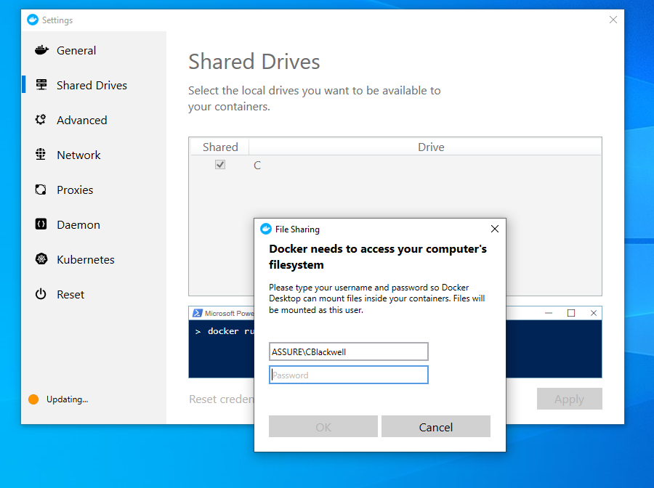

If you enter it correctly it should update your docker settings, but will error on the firewall

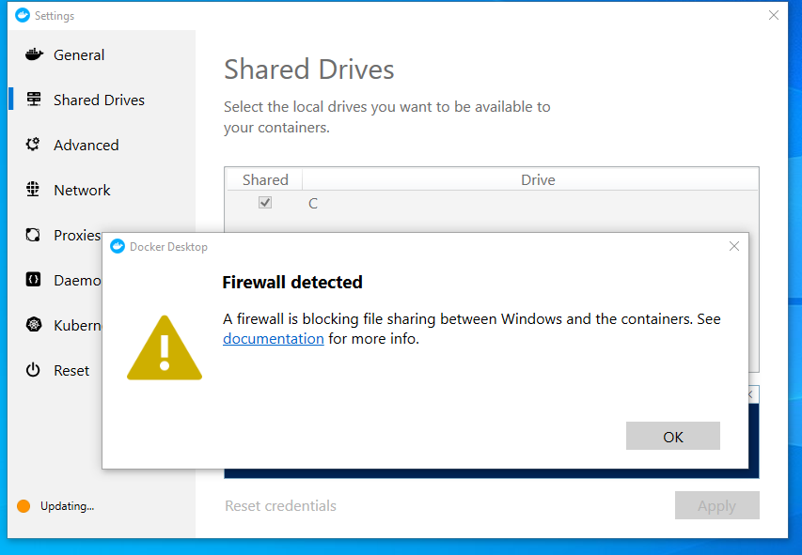

We need to disable the firewall option on the VPN software, even though we are not connected to the VPN. Right click on Checkpoint Endpoint Security, then click show client.

Click firewall, Disable Security Policy and click OK,

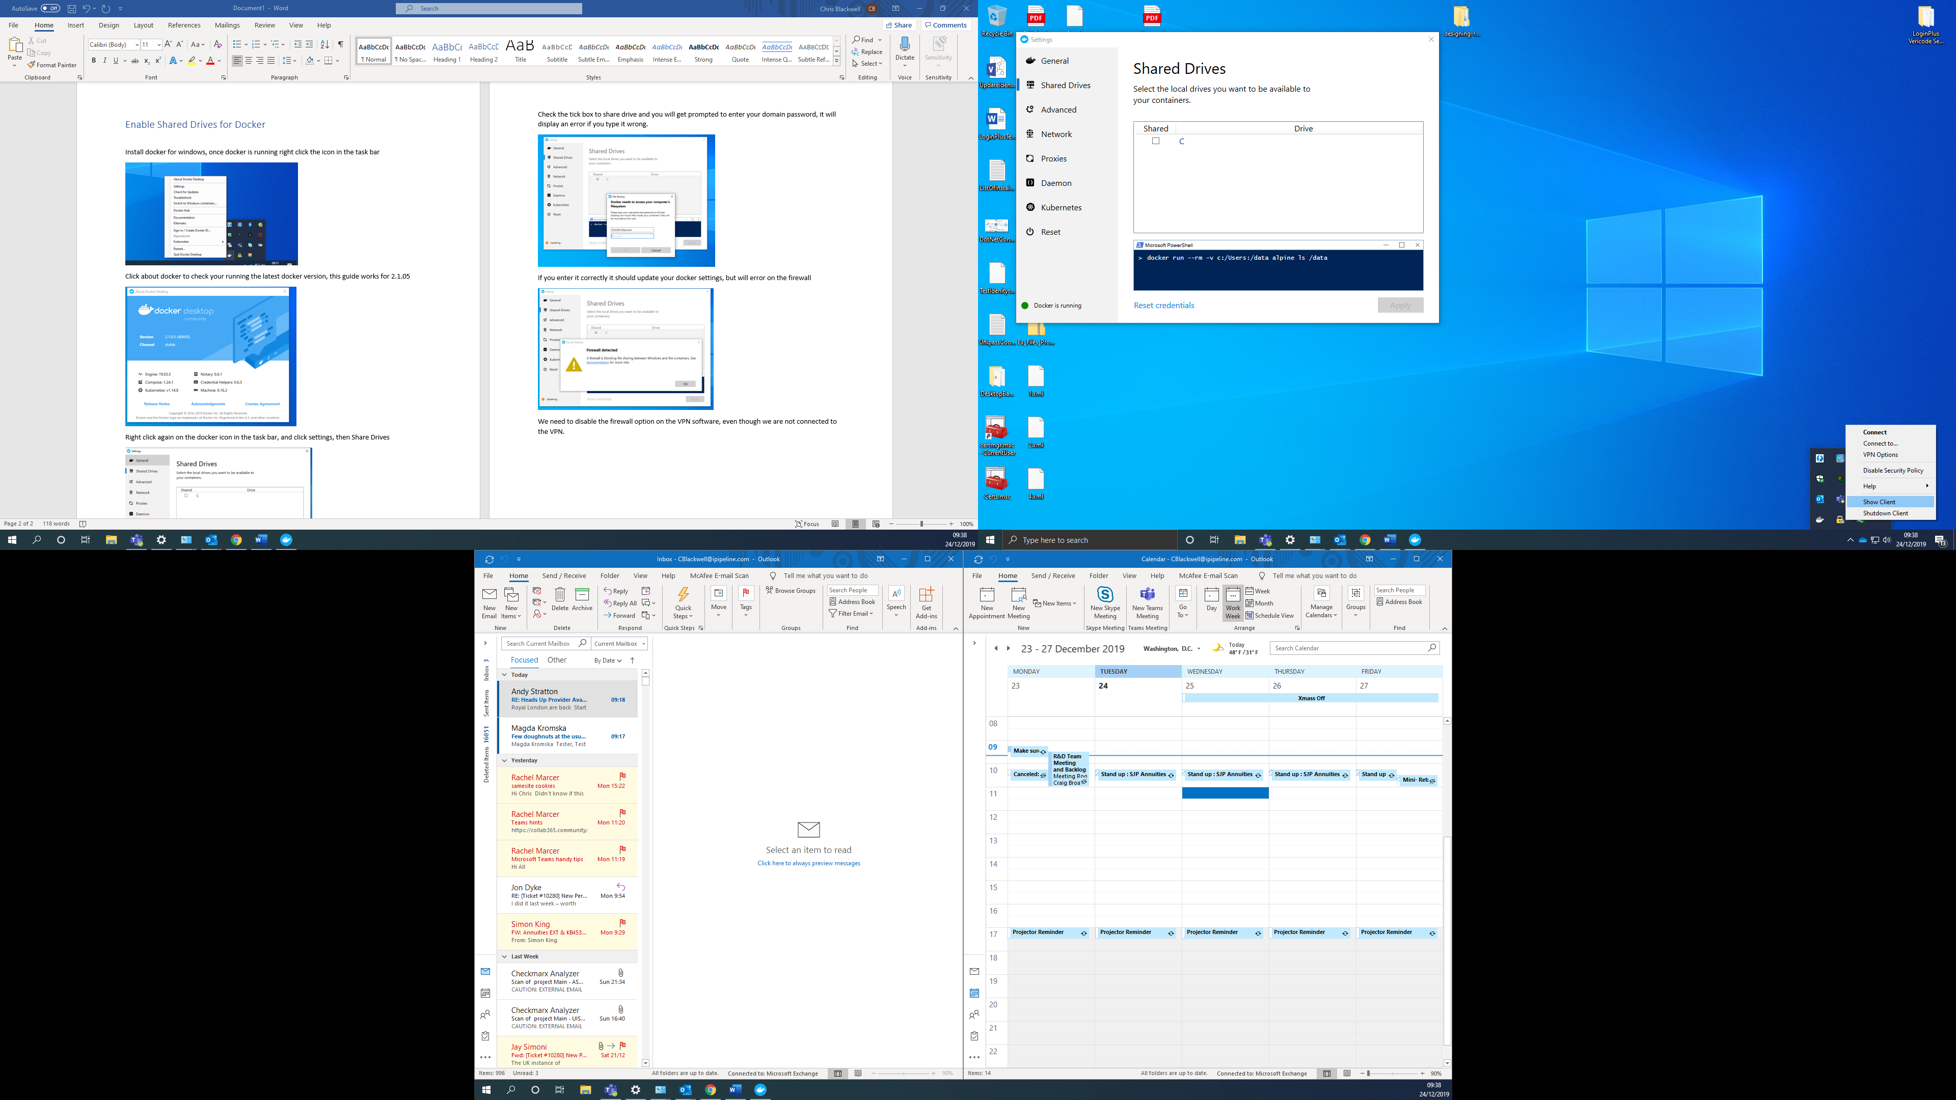 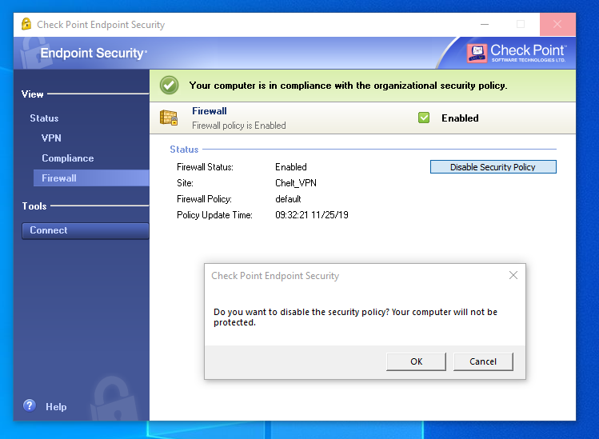

Its ok to leave your VPN Firewall Disabled, and we can now close the Check Point Endpoint Security.

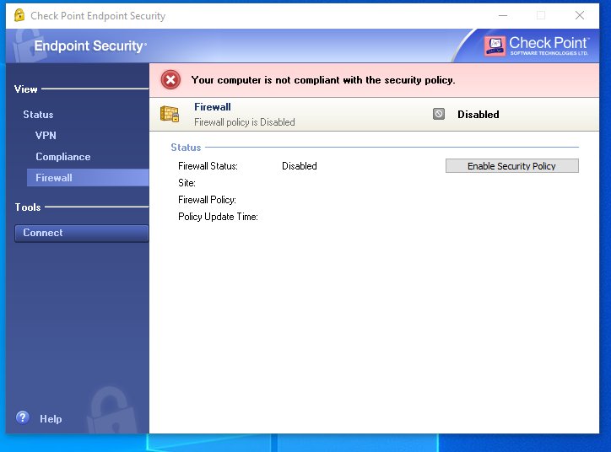 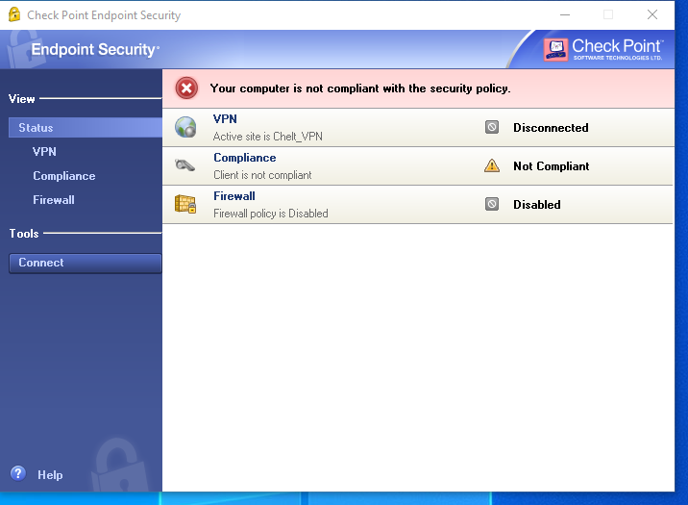

From here you should now be able to go back to Docker Setting and Share c drive should now work. You will also need to go to Proxies and click Manual proxy configuration, http://192.168.3.8:800/

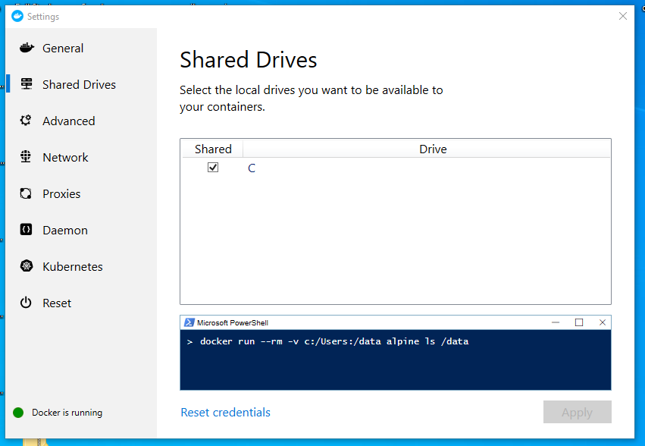 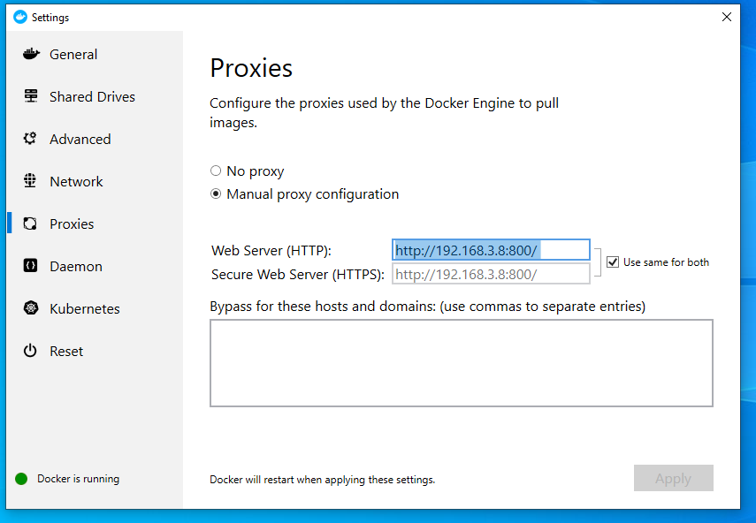

Now if you try and run a .Net Core Application with Docker support the error should go away and the application should now run.